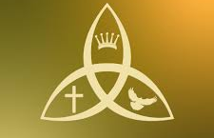
Trinity Sunday, Year A
Holy Eucharist, Rite II

Sunday, May 31, 2026, 10:00 am

The Rev. Dr. Pamela J. Stevens
The Rev. Dcn. Skip Bushee

St. Peter’s Episcopal Church, Redwood City
178 Clinton Street, Redwood City, CA 94062

www.stpetersrwc.org
Prelude

The Processional hymn A mighty fortress is our God, Hymnal 1982 # 688

The people stand and face the back of the sanctuary as the service begins, gradually turn their bodies to face the cross as it moves to the chancel. Traditionally, the people bow to the cross as it passes.
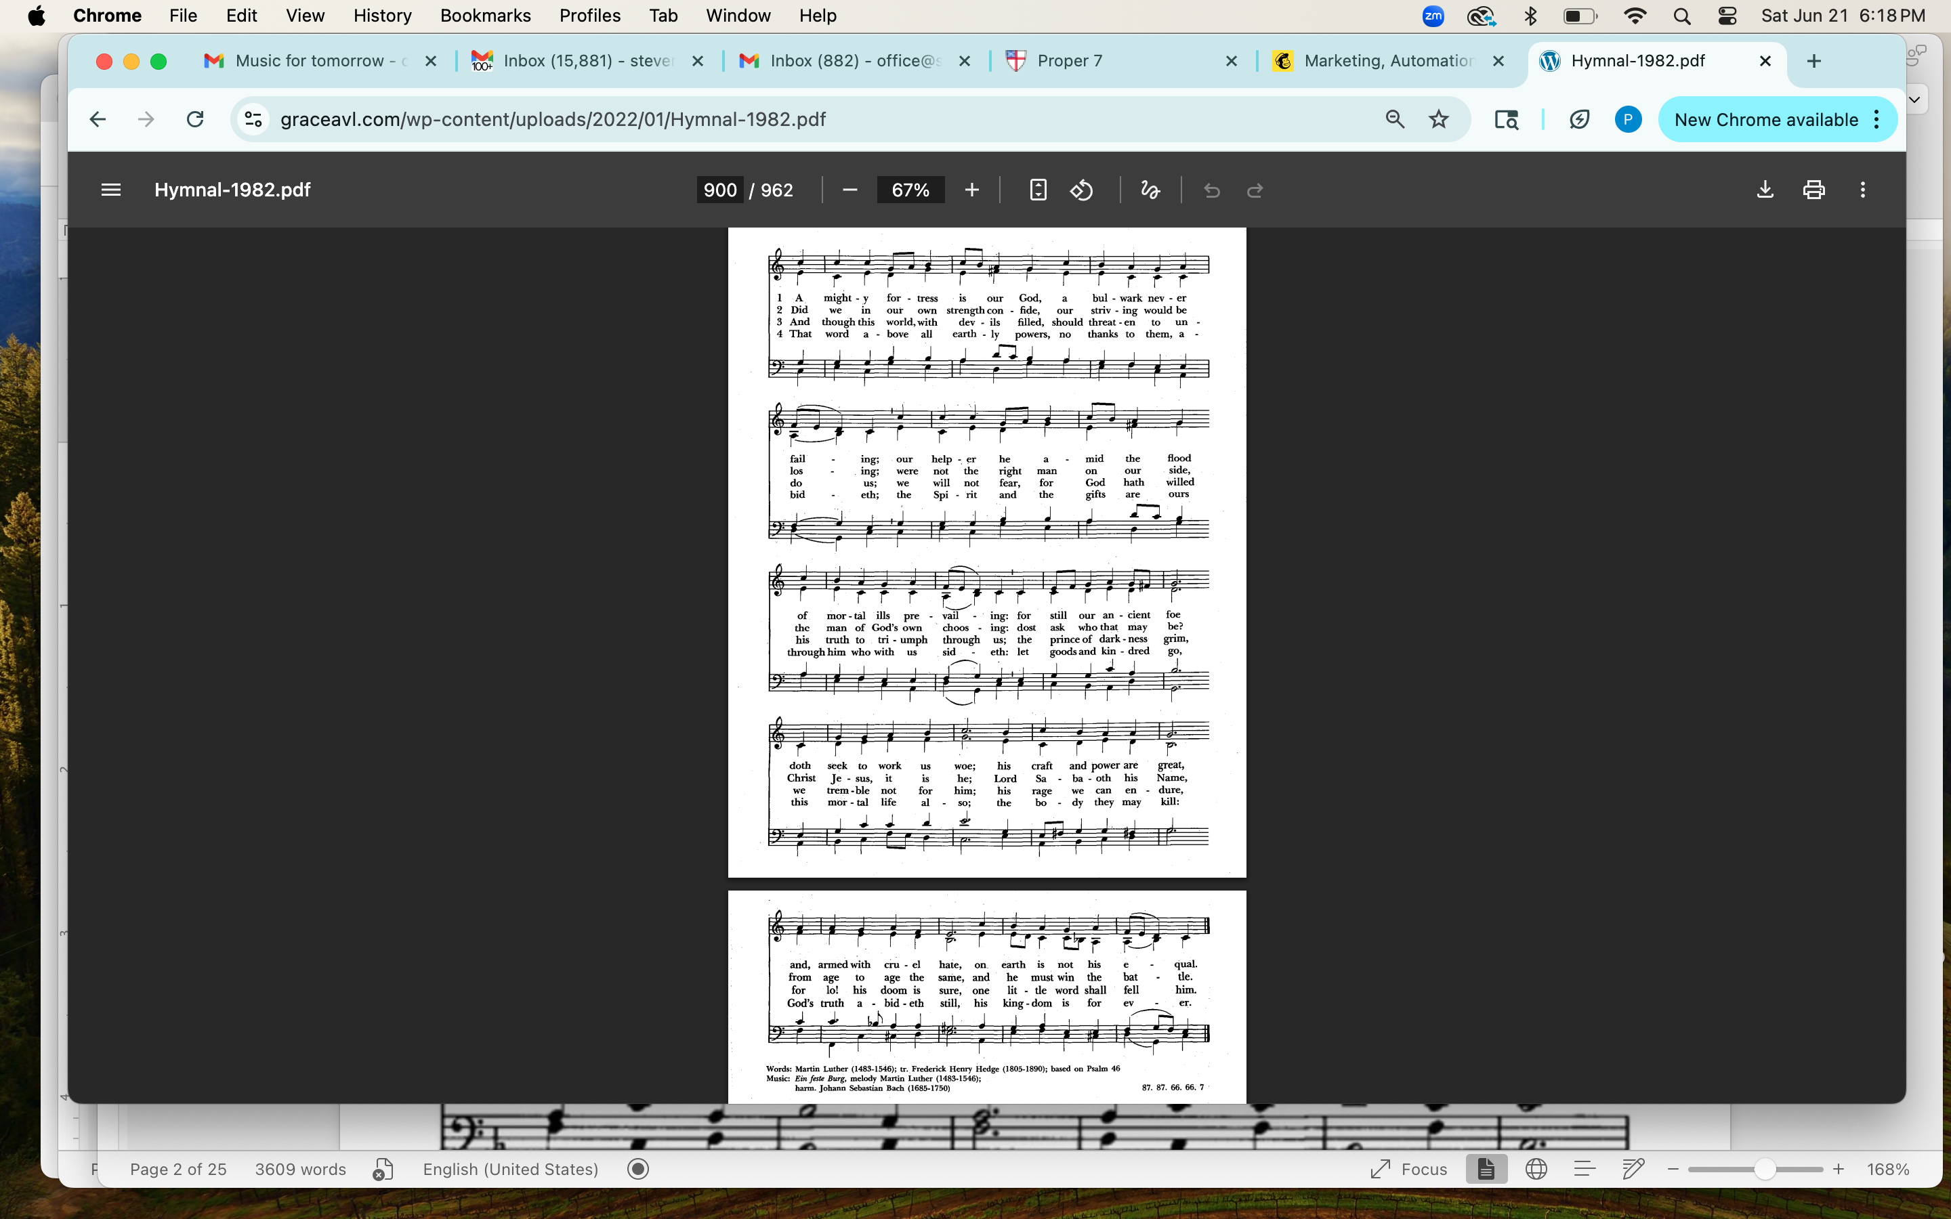

The Opening Acclamation

Celebrant
Blessed be God: Father, Son, and Holy Spirit.

People
And blessed be God’s kingdom, now and for ever. Amen.

Celebrant
Almighty God, to you all hearts are open, all desires known, and from you no secrets are hid: Cleanse the thoughts of our hearts by the inspiration of your Holy Spirit, that we may
perfectly love you, and worthily magnify your holy Name; through Christ our Lord. Amen.

Powell, Hymnal 1982 #S-280
The Gloria
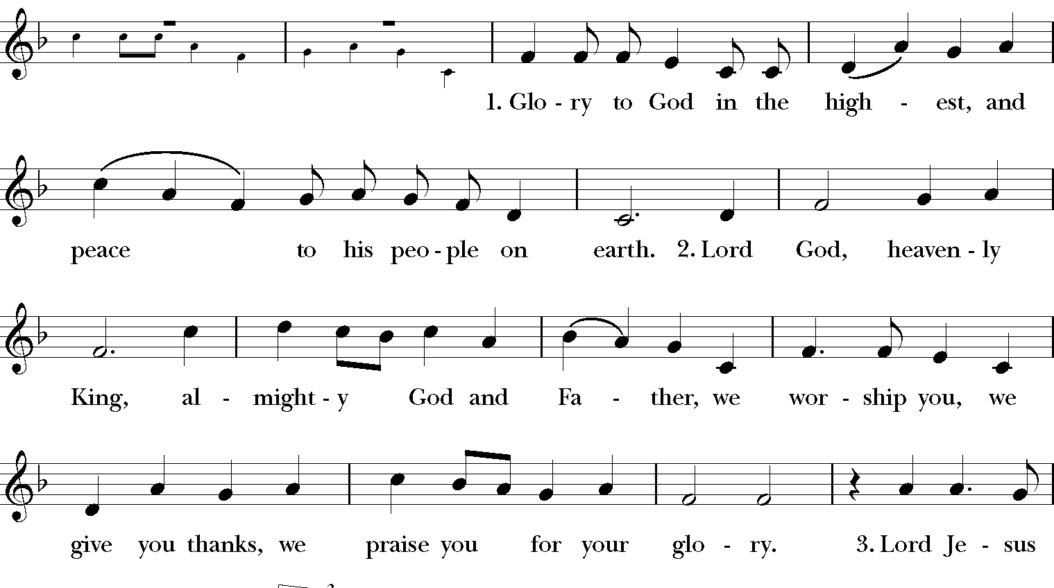

To God’s

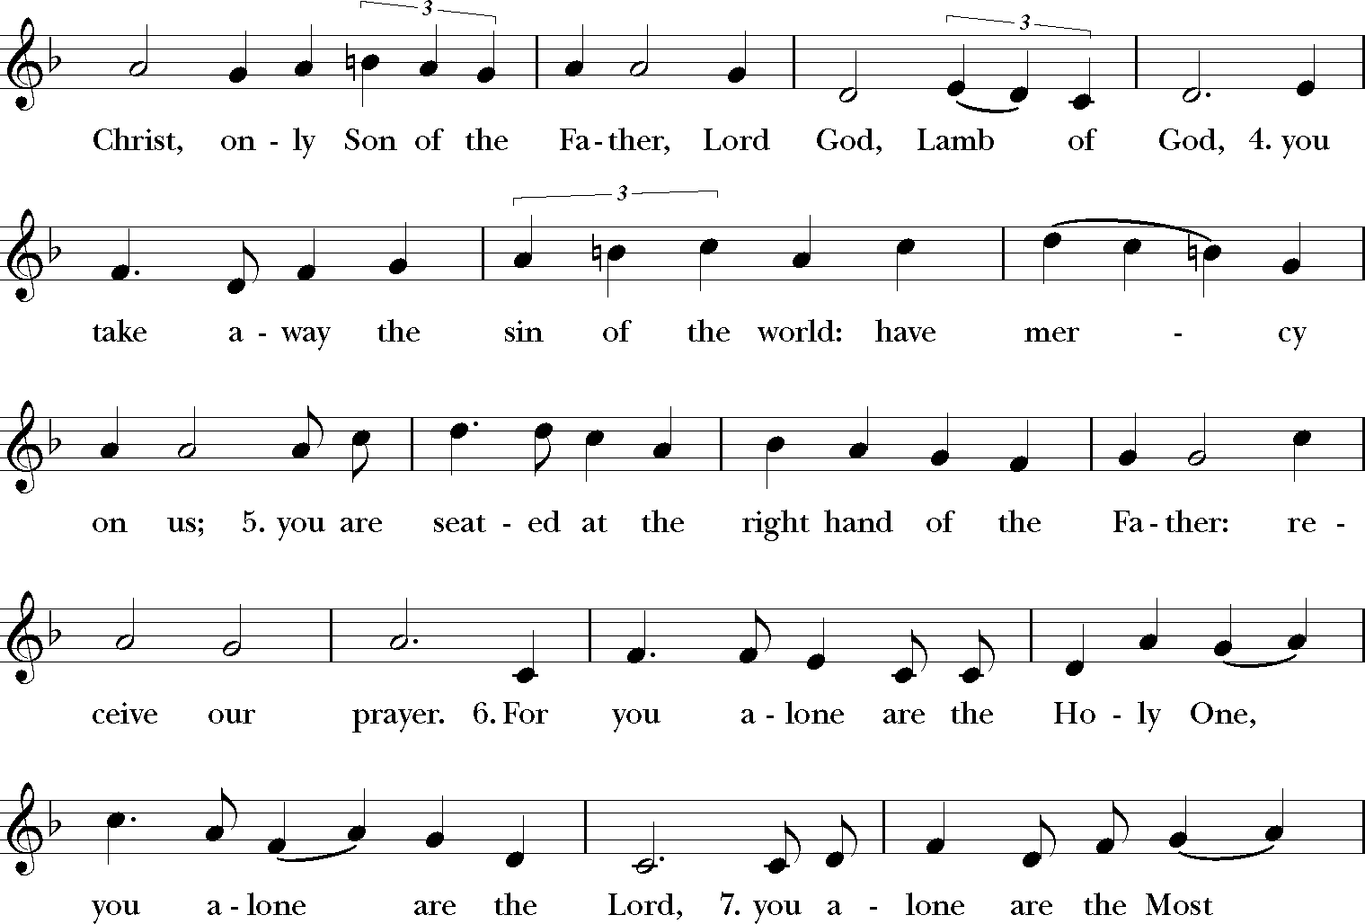

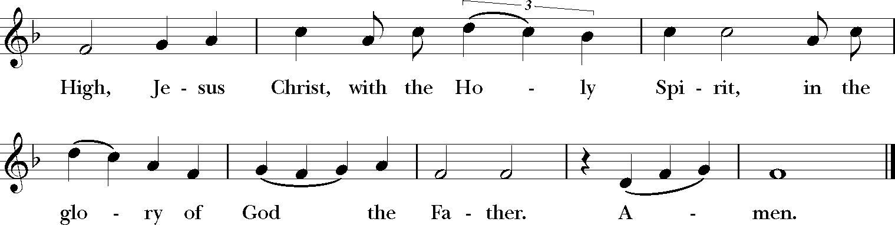

The Collect of the Day a “Collect” (CALL-ect) is a prayer said by one person on
behalf of the entire gathering
Celebrant
The Lord be with you.

People
And also with you.

Celebrant

Let us pray.

Almighty and everlasting God, you have given to us, your servants, grace by the confession of a true faith, to acknowledge the glory of the eternal Trinity, and in the power of your divine Majesty to worship the Unity: Keep us steadfast in this faith and worship, and bring us at last to see you in your one and eternal glory, O Father; who with the Son and the Holy Spirit live and reign, one God, for ever and ever. Amen.

The Liturgy of the Word

Celebrant
Let us be seated for the lessons

The Lesson From the Old Testament Genesis 1:1–2:4a

Lector

A reading from the book of the book of Genesis

In the beginning when God created the heavens and the earth, the earth was a formless void and darkness covered the face of the deep; a wind from God swept over the face of the waters. Then God said, “Let there be light”; and there was light. And God saw that the light was good; and God separated the light from the darkness. God called the light Day, and the darkness God called Night. And there was evening and there was morning, the first day.
And God said, “Let there be a dome in the midst of the waters, and let it separate the waters from the waters.” So God made the dome and separated the waters that were under the dome from the waters that were above the dome. And it was so. God called the dome Sky. And there was evening and there was morning, the second day.
And God said, “Let the waters under the sky be gathered together into one place, and let the dry land appear.” And it was so. God called the dry land Earth, and the waters that were gathered together he called Seas. And God saw that it was good.
Then God said, “Let the earth put forth vegetation: plants yielding seed, and fruit trees of every kind on earth that bear fruit with the seed in it.” And it was so. The earth brought forth vegetation: plants yielding seed of every kind, and trees of every kind bearing fruit with the seed in it. And God saw that it was good. And there was evening and there was morning, the third day.
And God said, “Let there be lights in the dome of the sky to separate the day from the night; and let them be for signs and for seasons and for days and years, and let them be lights in the dome of the sky to give light upon the earth.” And it was so.
God made the two great lights—the greater light to rule the day and the lesser light to rule the night—and the stars. God set them in the dome of the sky to give light upon the earth, to rule over the day and over the night, and to separate the light from the darkness. And God saw that it was good. And there was evening and there was morning, the fourth day.
And God said, “Let the waters bring forth swarms of living creatures, and let birds fly above the earth across the dome of the sky.” So God created the great sea monsters and every living creature that moves, of every kind, with which the waters swarm, and every winged bird of every kind. And God saw that it was good. God blessed them, saying, “Be fruitful and multiply and fill the waters in the seas, and let birds multiply on the earth.” And there was evening and there was morning, the fifth day.
And God said, “Let the earth bring forth living creatures of every kind: cattle and creeping things and wild animals of the earth of every kind.” And it was so. God made the wild animals of the earth of every kind, and the cattle of every kind, and everything that creeps upon the ground of every kind. And God saw that it was good.
Then God said, “Let us make humankind in our image, according to our likeness; and let them have responsibility over the fish of the sea, and over the birds of the air, and over the cattle, and over all the wild animals of the earth, and over every creeping thing that creeps upon the earth.”
So God created humankind in God’s image,
in the image of God, God created them;
male and female God created them.

God blessed them, and God said to them, “Be fruitful and multiply, and fill the earth and cultivate it; and tend the fish of the sea and care for thee birds of the air and over every living thing that moves upon the earth.” God said, “See, I have given you every plant yielding seed that is upon the face of all the earth, and every tree with seed in its fruit; you shall have them for food. And to every beast of the earth, and to every bird of the air, and to everything that creeps on the earth, everything that has the breath of life, I have given every green plant for food.” And it was so. God saw everything that God had made, and indeed, it was very good. And there was evening and there was morning, the sixth day.

Thus the heavens and the earth were finished, and all their multitude. And on the seventh day God finished the work that God had done, and God rested on the seventh day from all the work that God had done. So God blessed the seventh day and made it holy, because on it God rested from all the work that God had done creation.

These are the generations of the heavens and the earth when they were created.
The Word of the Lord.
People | Thanks be to God.

The Response Psalms 8

Lector
We will read the Psalm responsively at the half-verse.

¹ O Lord who governs us, *
how exalted is your Name in all the world!

² Out of the mouths of infants and children *
your majesty is praised above the heavens.

³ You have set up a stronghold against your adversaries, *
to quell the enemy and the avenger.

⁴ When I consider your heavens, the work of your fingers, *
the moon and the stars you have set in their courses,

⁵ What is humanity that you should be mindful of humans? *
the offspring of humans hat you should seek us out?

⁶ You have made humanity but little lower than the angels; *
you adorn humanity with glory and honor;

⁷ You give humanity mastery over the works of your hands; *
you put all things under his feet:

⁸ All sheep and oxen, *
even the wild beasts of the field,

⁹ The birds of the air, the fish of the sea, *
and whatsoever walks in the paths of the sea.

¹⁰ O Lord who governs us, *
how exalted is your Name in all the world!

The Lesson from the Epistles: 2 Corinthians 13:11–13

Lector:
A reading from the second letter of St. Paul to the Corinthians

Finally, siblings, farewell. Put things in order, listen to my appeal, agree with one another, live in peace; and the God of love and peace will be with you. Greet one another with a holy greeting. All the saints greet you.
The grace of the Lord Jesus Christ, the love of God, and the communion of the Holy Spirit be with all of you.
The Word of the Lord.

People
Thanks be to God.

The Gradual Hymn Holy, Holy, Holy, Lord God Almighty

The People stand. A member of the clergy carries the Gospel among the People for the Proclamation. The People turn to face the Gospel.

The service continues on the following page.

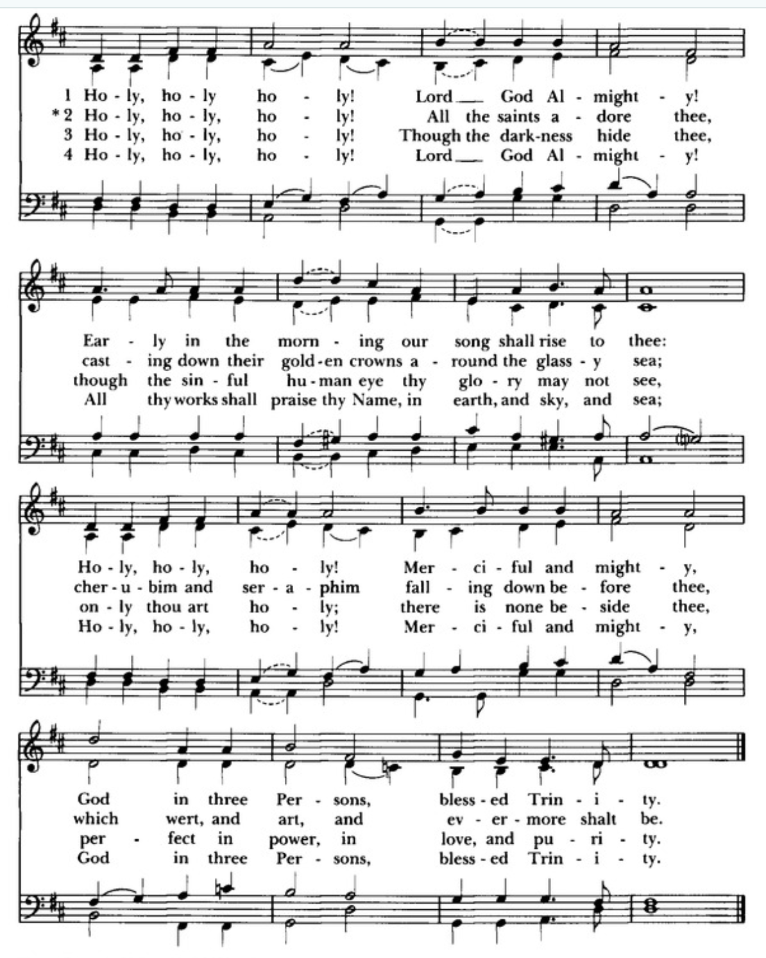
Traditionally, as the clergy member says “The Holy Gospel of our Lord Jesus Christ at the beginning of the proclamation, the people may make three small crosses over the forehead, lips, and heart.
Matthew 28:16–20

The Gospel

Clergy:
The Holy Gospel of our Lord Jesus Christ according to St. Matthew

People:
Glory to you, Lord Christ

Clergy:
The eleven disciples went to Galilee, to the mountain to which Jesus had directed them. When they saw him, they worshiped him; but some doubted. And Jesus came and said to them, “All authority in heaven and on earth has been given to me. Go therefore and make disciples of all nations, baptizing them in the name of the Father and of the Son and of the Holy Spirit, and teaching them to obey everything that I have commanded you. And remember, I am with you always, to the end of the age.”
The Gospel of the Lord.
People
Praise to you, Lord Christ.

The Sermon The Rev. Dr. Pamela Stevens

The Nicene Creed The People stand.

We believe in one God,
the Father, the Almighty,
maker of heaven and earth,
of all that is, seen and unseen.
We believe in one Lord, Jesus Christ,
the only Son of God,
eternally begotten of the Father,
God from God, Light from Light,
true God from true God,
begotten, not made,
of one Being with the Father.
Through him all things were made.
For us and for our salvation
he came down from heaven:
by the power of the Holy Spirit
he became incarnate from the Virgin Mary,
and was made man.
For our sake he was crucified under Pontius Pilate;
he suffered death and was buried.
On the third day he rose again
in accordance with the Scriptures;
he ascended into heaven
and is seated at the right hand of the Father.
He will come again in glory to judge the living and the dead,
and his kingdom will have no end.
We believe in the Holy Spirit, the Lord, the giver of life,
who proceeds from the Father and the Son.
With the Father and the Son he is worshiped and glorified.
[She]* has spoken through the Prophets.
We believe in one holy catholic and apostolic Church.
We acknowledge one baptism for the forgiveness of sins.
We look for the resurrection of the dead,
and the life of the world to come. Amen.

The Prayers of the People Common Worship,
Church of England, p. 497, adapted
A moment of silence follows.

Intercessor
Let us pray for God to fill us with the Spirit.

Generous God, we thank you for the power of you, whom we receive as the Holy Trinity. We ask that we and those who lead among us may be strengthened to serve you more fully, remembering especially Sean our Presiding Bishop, and Austin our Bishop, Pamela our priest, Skip, our deacon; Deborah, Terei, Dianne, RuthAnne, Elaine, and Lori our vestry members; and all who serve in the church.

People
Creator, Redemer, Sustainer, hear our prayer.

Intercessor
We thank you, the Unity of the One God, Father, Son, and Holy Spirit. We ask you to grant us insight to understand your will. Bless with discernment and moderation those who bear the authority of government. May they serve with honor, seeking justice and peace.

People
Creator, Redemer, Sustainer, hear our prayer.

Intercessor
Gracious and unified God, we thank you for peace. We ask you to keep us confident of power, full of your love, and aware of your presence among us. May we go wherever you call us. dWe pray that you will encourage and protect all those working today for the good of their communities and the health of the world.

People
Creator, Redemer, Sustainer, hear our prayer.

Intercessor
God who made, gave, and is ever present, we ask you to bring reconciliation and wholeness wherever there is division, sickness, and sorrow. We pray for all those around the world affected by war, violence, and oppression, and for those who have commended themselves to our prayers, especially those we name now, silently or aloud.

The People reflect on those whom they know they who face challenges, and offer up their names for prayer.

Intercessor
We lift these to your care.

People
Creator, Redemer, Sustainer, hear our prayer.

Intercessor
We thank you for the comfort you provide when we mourn, and for the confidence we have that death is not an end but a transition. We pray for all who have died, and those we name now, silently or aloud.

The People reflect on those who have gone before them in death, offering their names for prayer.

Intercessor
that they may rest with you in eternal light and love.

People
Creator, Redemer, Sustainer, hear our prayer.

Intercessor
God, we ask you to equip us for the work which you have given us. Commit this congregation afresh to its core values of faith, welcome, compassion, social justice, and outreach.

People
Creator, Redemer, Sustainer, hear our prayer.

Intercessor
God, we ask you to reveal the love of God, through Jesus Christ and the Holy Spirit through us in our lives. We ask you to keep the whole Church, living and departed, in the joy of eternal life.

People
Creator, Redemer, Sustainer, hear our prayer.
Silence

Celebrant
Generous and loving God in three persons, who Created us, Redeems us, and moves among us, we pray that you will give us the strength of spirit to serve you in a fallen world; to speak truths of justice that are unpopular, to be willing to initiate change even when it’s hard, and to courageously face personal trials, trusting in your love and provision. Amen.

People Amen.

The Confession and Absolution (the people remain standing)

Celebrant
Let us confess our sins against God and our neighbor.

A moment of silence follows.
Celebrant and People

Most merciful God,
we confess that we have sinned against you
in thought, word, and deed,
by what we have done,
and by what we have left undone.
We have not loved you with our whole heart;
we have not loved our neighbors as ourselves.
We are truly sorry and we humbly repent.
For the sake of your Son Jesus Christ,
have mercy on us and forgive us;
that we may delight in your will,
and walk in your ways,
to the glory of your Name. Amen.

Celebrant

Almighty God have mercy on you, forgive you all your sins through our Lord Jesus Christ, strengthen you in all goodness, and by the power of the Holy Spirit keep you in eternal life. Amen.

The Peace

Celebrant | The peace of the Lord be always with you.
People | And also with you.

The People exchange a sign of the peace, typically hands in prayer position with a small bow saying, “Peace,” or some other greeting such as “May the Peace of the Lord be with you.”

Observances of Life Events

The Celebrant will invite the congregation to offer prayers for blessings of those with birthdays and anniversaries with the following prayers.

For Birthdays
Watch over your children, O Lord, as their days increase; bless and guide them wherever they may be. Strengthen them when they stand; comfort them when discouraged or sorrowful; raise them up if they fall; and in their heart may your peace which passes understanding abide all the days of their life; through Jesus Christ our Lord. Amen.

For Marriage Anniversaries
O God, You have so consecrated the covenant of marriage that in it is represented the spiritual unity between Christ and his Church; Send therefore your blessing upon these your servants N. and N., that they may so love, honor, and cherish each other in faithfulness and patience, in wisdom and true godliness, that their home may be a haven of blessing and peace; through Jesus Christ our Lord, who lives and reigns with you and the Holy Spirit, one God, now and for ever. Amen.

For Travelers
O God, our heavenly Father, whose glory fills the whole creation, and whose presence we find wherever we go: Preserve those who travel [in particular _______________]; surround them with your loving care; protect them from every danger; and bring them in safety to their journey's end; through Jesus Christ our Lord. Amen.

News and Announcements

The Sr. Warden Emerita will share the news of the day and upcoming events.

The Offertory

The Celebrant will announce the commencement of the Offertory.

Walk in love, as Christ loved us and gave himself for us, an offering and sacrifice to God. (Ephesians 5:2)

Ushers will pass the plate for an optional offering to the church for its mission
and ministry. Thank you for your generosity.

Electronic donations are welcome:



The Offertory Hymn All things bright and beautiful
Hymnal 1982 #518

The People remain seated for the hymn, then stand at its conclusion as the musician begins the Doxology and the gifts are presented at the altar.



The service continues on the next page with the hymn.
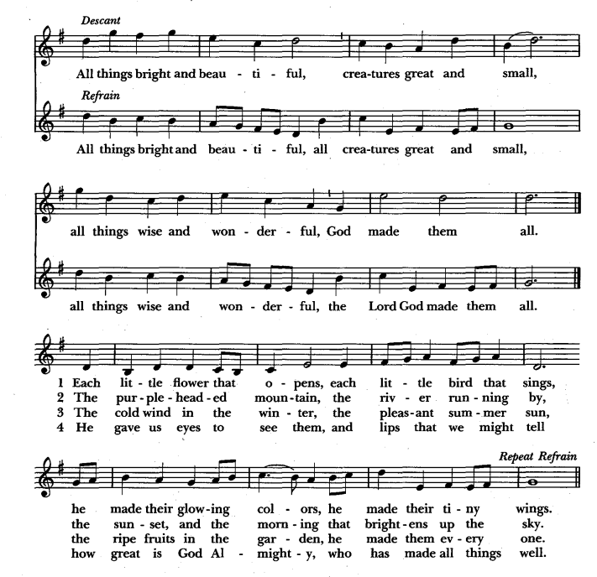
God

God
who

God made

God

The Doxology and the Presentation of Gifts

The People stand.

A-men

The Great Thanksgiving Eucharistic Prayer B, BCP

The People stand.

Celebrant
 | The Lord be with you.
People | And also with you.
Celebrant | Lift up your hearts.
People | We lift them to the Lord.
Celebrant | Let us give thanks to the Lord our God.
People | It is right to give [God] thanks and praise.

Celebrant
It is right, and a good and joyful thing, always and everywhere to give thanks to you, Father Almighty, Creator of heaven and earth.
For with your co-eternal Son and Holy Spirit, you are one God, one Lord, in Trinity of Persons and in Unity of Being; and we celebrate the one and equal glory of you, O Father, and of the Son, and of the Holy Spirit.

Therefore we praise you, joining our voices with Angels and Archangels and with all the company of heaven, who for ever sing this hymn to proclaim the glory of your Name:

The Sanctus Holy, holy holy, Schubert, Deutsche Messe

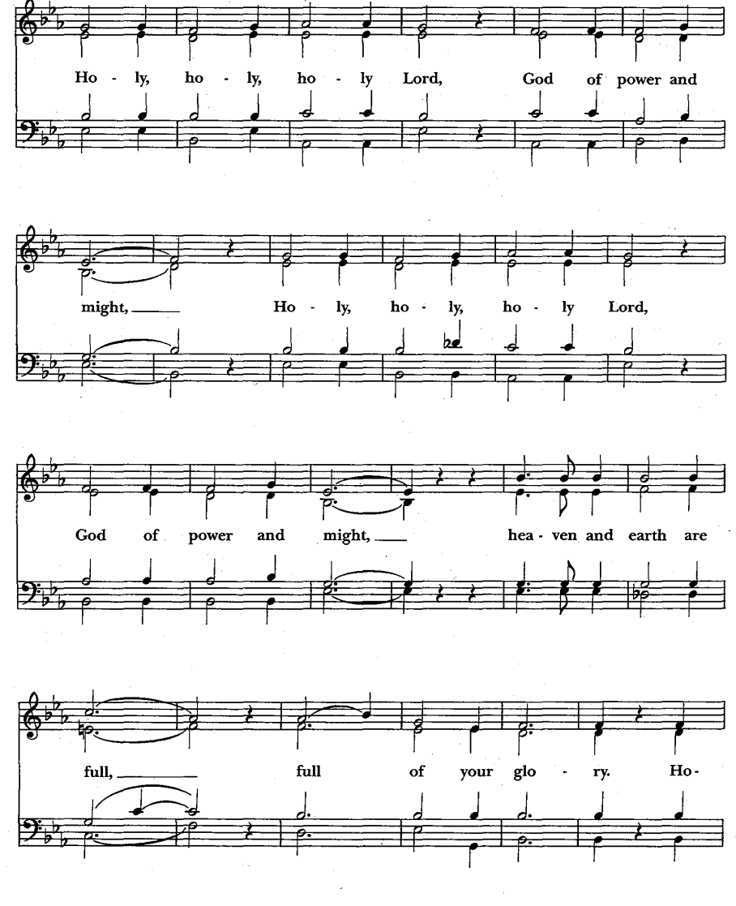
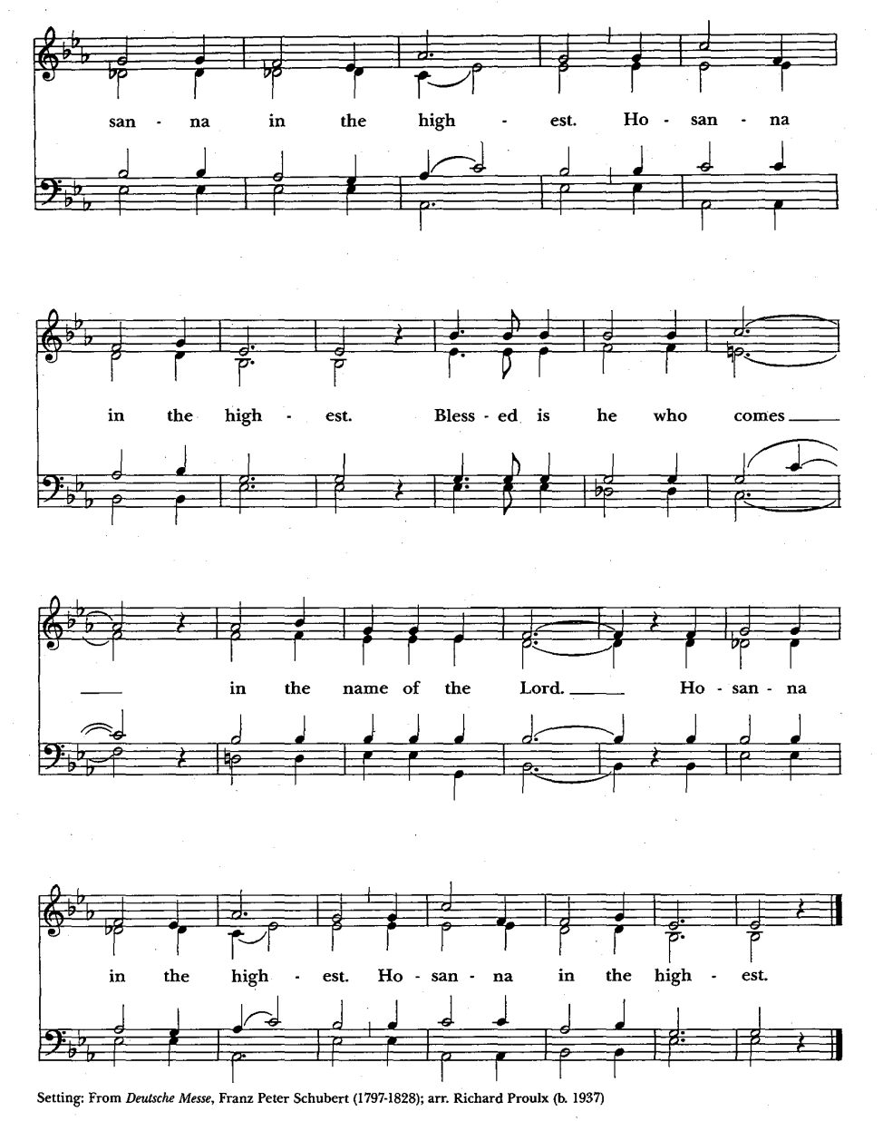

The people stand or kneel. The Celebrant continues

We give thanks to you, O God, for the goodness and love which you have made known to us in creation; in the calling of Israel to be your people; in your Word spoken through the prophets; and above all in the Word made flesh, Jesus, your Son. For in these last days you sent him to be incarnate from the Virgin Mary, to be the Savior and Redeemer of the world.
In him, you have delivered us from evil and made us worthy to stand before you. In him, you have brought us out of error into truth, out of sin into righteousness, out of death into life.

On the night he was handed over to suffering and death, our Lord Jesus Christ took bread; and when he had given thanks to you, he broke it, and gave it to his disciples, and said, "Take,
eat: This is my Body, which is given for you. Do this for the remembrance of me."

After supper he took the cup of wine; and when he had given thanks, he gave it to them, and said, "Drink this, all of you: This is my Blood of the new Covenant, which is shed for you and for many for the forgiveness of sins. Whenever you drink it, do this for the remembrance of me."

Therefore we proclaim the mystery of faith:

Celebrant and People
Christ has died.
Christ is risen.
Christ will come again.

The Celebrant continues

And we offer our sacrifice of praise and thanksgiving to you, O Lord of all; presenting to you, from your creation, this bread and this wine.

We pray you, gracious God, send your Holy Spirit upon these gifts that they may be the Sacrament of the Body of Christ and his Blood of the new Covenant. Unite us to your
Son in his sacrifice, that we may be acceptable through him, being sanctified by the Holy Spirit. In the fullness of time, put all things in subjection under your Christ, and bring us to that heavenly country where, with St. Mary and St. Peter and all your saints, we may enter the everlasting heritage of your sons and daughters; through Jesus Christ our Lord, the firstborn of all
creation, the head of the Church, and the author of our salvation. By him, and with him, and in him, in the unity of the Holy Spirit all honor and glory is yours, Almighty Father, now and
for ever. Amen.

And now, as our Savior Christ has taught us, we are bold to say,

People and Celebrant
Our Father, who art in heaven,
hallowed be thy Name,
thy kingdom come,
thy will be done,
on earth as it is in heaven.
Give us this day our daily bread.
And forgive us our trespasses,
as we forgive those
who trespass against us.
And lead us not into temptation,
but deliver us from evil.
For thine is the kingdom,
and the power, and the glory,
for ever and ever. Amen.

The Fraction Hymn Christ our Passover is sacrificed for us
Hymnal 1982 S-154
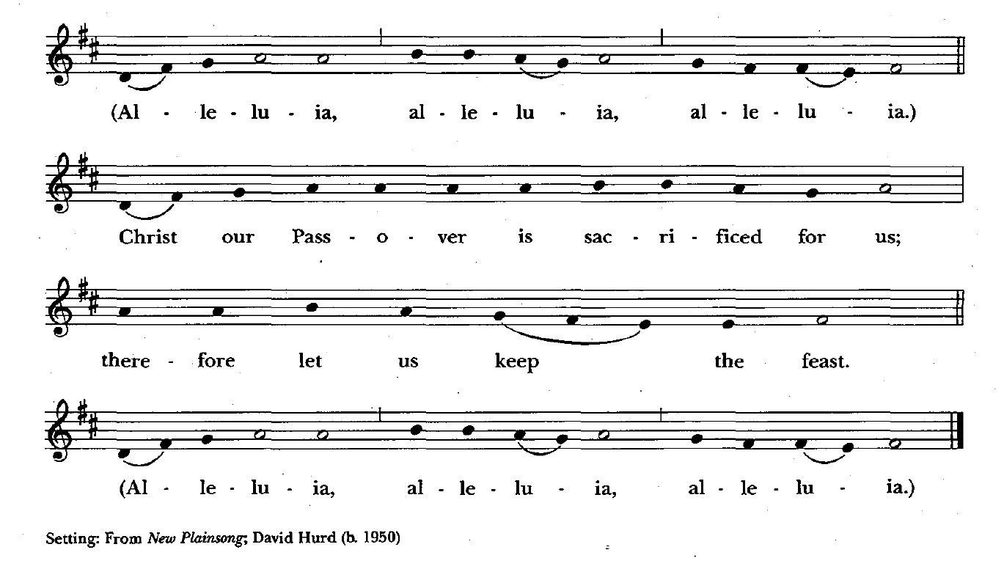

Celebrant
The gifts of God for the People of God.

Take them in remembrance that Christ died for you, and feed on him in your hearts by faith, with thanksgiving.

The Administration of Communion

At St. Peter’s it is our practice is to receive the host, then dip (intinct) it into the wine before consuming it. Wine and grape juice are available, as is gluten-free host.

The Bread and the Cup are given to the communicants with these words

The Body of Christ, the bread of heaven. [Amen.]
The Blood of Christ, the cup of salvation. [Amen.]

The Communion Hymn Let us break bread together on our knees
Hymnal 1982 #325 (see next page)

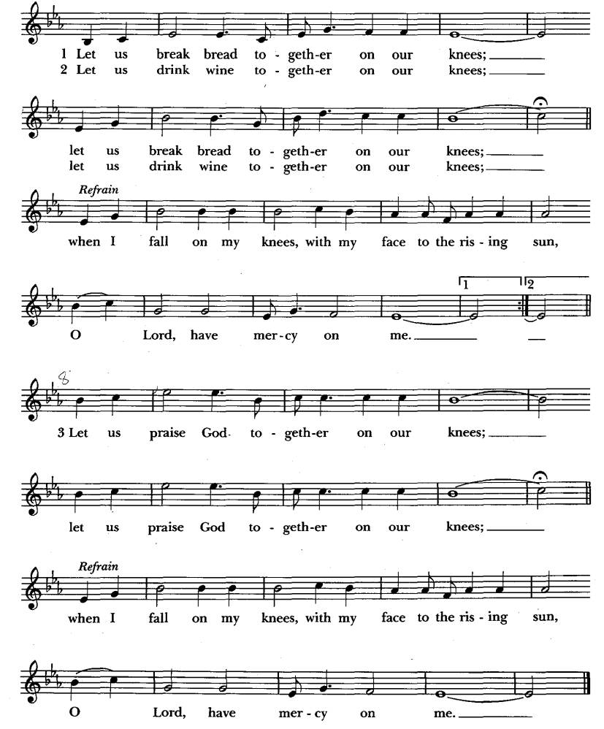

The Prayer After Communion

Celebrant
Let us pray.

Celebrant and People
Eternal God, heavenly Father,
you have graciously accepted us as living members
of your Son our Savior Jesus Christ,
and you have fed us with spiritual food
in the Sacrament of his Body and Blood.
Send us now into the world in peace,
and grant us strength and courage
to love and serve you
with gladness and singleness of heart;
through Christ our Lord. Amen.
The Blessing

Celebrant

May we who are made in the image of God break down the walls the separate us from each other and from the whole of Creation. And may the blessing of God, the Father, the Son, and the Holy Spirit, be with you now and always. Amen.

The Recessional Hymn Christ is made the sure foundation
Hymnal 1982 # 518

The altar party will recess, following the cross. The People, following the cross, turn to face the back of the sanctuary. The dismissal follows the hymn.

The hymn follows on the next page.

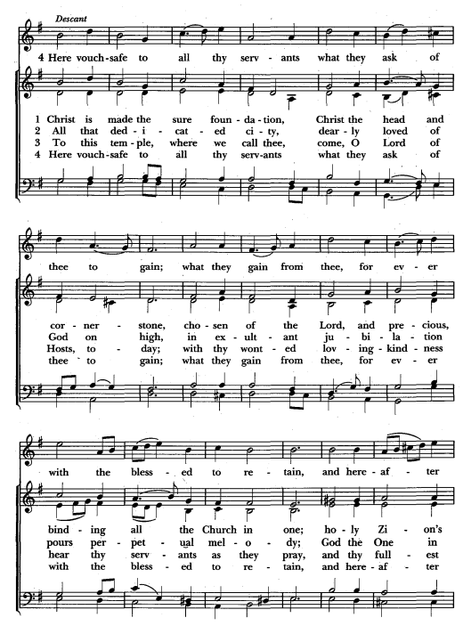

The Dismissal

Clergy Go in peace to love and serve the Lord. Alleluia, Alleluia.
People: Thanks be to God Alleluia, Alleluia.

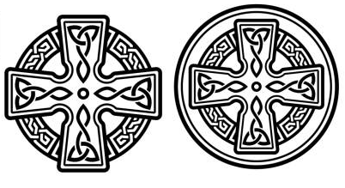

ALL ARE WELCOMEE, JOIN US FOR COFFEE HOUR IN THE PARISH HALL!

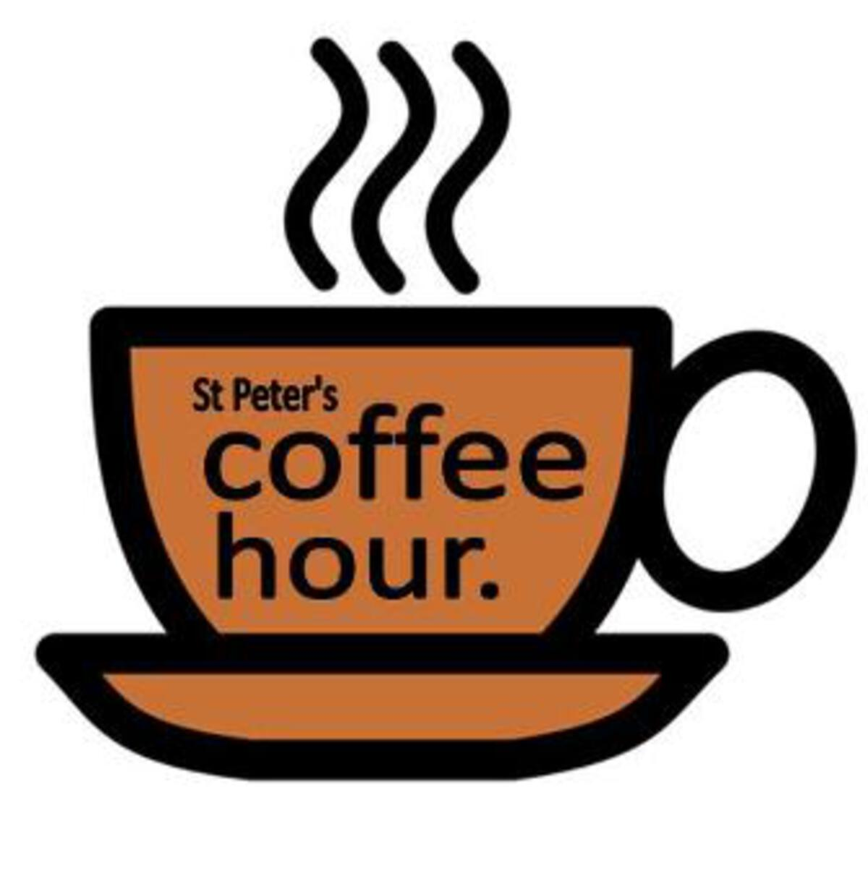

Upcoming Events at St. Peter’s Redwood City

St. Peter’s Workday, Saturday, June 6, 9am - 12pm
St. Peter’s next monthly workday will be held on Saturday, June 6, from 9am - 12pm.
- We will work primarily doing yard work on the project to create the Peggie Trei Memorial Garden.

DAY CAMP POSTPONED!
We have had to postpone the Vacation Choir Camp originally scheduled for
June 8-12
- Due to necessary fogging in the building to abate pests, and a requirement to limit the presence of children before, during, and after the process, we have ha to postpone the Vacation Choir Camp.
- A new date will be announced for August.

Mark your calendars! St Peter’s Pop-Up—Thrift-Store is coming! Saturday June 27 8am - 3pm in front of the church and in the Parish Hall.
- “Thrift” refers to the very reasonable prices for the “nearly new” merchandise, and it’s a bit like treasure-hunting!
- We are seeking an inventory to sell to raise funds for St. Peter’s! Do you have small furniture pieces, clothing (clean, stain-free), shoes, linens, art work (framed or neatly presented), potted plants, household/kitchen items, books, etc. that you can donate?
- It’s not too early to start your spring cleaning. Your family and friends can donate, too! Think satisfaction, fun and tax write-off (we do not issue receipts for donated goods, but you can make a list of what you donated if you itemize). We will start collecting items soon. We will need volunteers for advertising, sorting, pricing, selling, set-up and
tear-down/cleanup. Look for sign-up sheets and be thinking about how you can help!
- June 1: We will start collecting items at the back of the sanctuary.
  - We will collect items:
  - Fridays June 5, 12 &amp; 19 12-2 and 4-6, Saturdays June 6, 13 &amp; 20 10-1, or by appointment., And after the June 7, 14 &amp; 21 Sunday services. The last day to accept items will be Sunday June 21.
- We need help especially on Wednesday June24 (sort items); Thursday June 25 (tag and price items); Friday June 26 (set-up the Pop-Up and accept baked goods); Saturday June 27 all hands on deck! Items will be set up on the lawn and in the parish hall; Sunday June 28 left over items will be on sale at a discount for parishioners, then donated to a permanent local thrift store.

S
St. Peter’s Redwood City Fourth of July Parade Float Saturday, July 4.
- St. Peter’s has been approved for a musical float honoring 250 years of American Independence, and 177 years of parish history in Redwood City!
- A pickup truck with a conductor and keyboard will tow a flatbed trailer featuring a church choir.
- Interested in singing in the choir? Please reach out to Thomas Williams, twilliams@stpetersrwc.org.

Rev. Pamela’s Installation by our Bishop as the Rector of St. Peter’s, Saturday,
August 15, 11am:
- The Saturday morning service and luncheon is the Rite of Celebration of a
New Ministry. Our Bishop, the Rt. Rev. Austin Rios, will preach and
Preside.

